**Controlling Robot Car Movement Using Hand Gesture Recognition**

***Abstract***

**This paper describes the implementation of movement control for robotic car using hand gesture recognition which uses deep learning algorithm. Therefore, proposed technique is hassle free as control is not based on joysticks or switches. There are six conditions considered for robot car movement control as ‘Backword’, ‘Forward’, ‘Left’, ‘No-Motion’, ‘Right’ and ‘Stop’ using different hand gestures. There are many researchers worked on this area using different sensors, machine learning algorithms and deep learning algorithms. Limitations of the state of art techniques are studied in this paper and designed a new modified convolutional neural network (CNN) for gesture recognition which controls movement of robot car. Dataset is created which generates 1000 Gray scale images for each type of gesture. Training modified CNN model gives prediction accuracy of 98.4024 % while random forest machine learning classifier gives prediction accuracy of 69%. It is observed that proposed model gives better accuracy compared to state of art technique for controlling movement of robot car using hand gesture. Obtained hand gesture class can be send to robot using Arduino controller for controlling movement.**

***Keywords:*** **Robot Car Movement, Gesture Recognition, Random Forest, Deep Learning, CNN, layer modification, Arduino-Uno Controller**.

1. **Introduction**

Controlling a robot car has many benefits in industries, for disabled person, in chemical laboratories, in defence, etc. There is huge demand of robot car based on automatic movement without use of switches and joystick.

Robot car can be controlled with hand gesture recognition and it has many applications such as manufacturing, medical, military, construction sectors. Hand gestures can be recognised to move the robotic car in five different directions such as stop, forward, backward, left and right.

Different services and operations can be handled to robot as it is intelligent machine. Productivity of the work is increased by using robot as time required to perform task is very less for robotic car. There basically two categories of robotic cars as robotic cars controlled by remote and second one is robotic car controlled autonomously. Robotic car controlled by remote includes robot controlled by gestures. Robots controlled autonomously includes line and edge sensing robot [1].

Human feelings can be shared using either sign language or hand gestures. Without use of tele-operated robots and special hardware, with the help of gestures as well as sign, robotic movement can be controlled. With the help of temporal features hand or sign can be identified which then send to robot using controller [2].

Today’s world demands autonomous system which gives response very rapid without intervention of human being. Robotics field is growing very rapidly as per the technology demand causing harm to human. Robot need to be more precise to get real time environment. Mouse and keyboards are used in traditional methods for controlling robot. Image processing technique plays major role in hand gesture recognition-based robot control. Implemented algorithm should be invariant to factors like rotation, orientation, scaling, etc. Gaming field also uses gesture-based device control for interactive application [3].

Introduction to robotic car movement based on hand gesture recognition is explained in chapter I, in chapter II , literature survey of existing works is explained. Chapter III , discuss about proposed methodology while chapter IV , describes results analysis and conclusion is explained at the end.

1. **Existing techniques**

There are all ML algorithms used previously are existing algorithms as they are giving very less accuracy of hand gesture recognition. So in proposed work we have used CNN which is deep learning technique for hand gesture recognition.

Below are the basic machine learning techniques used ,

Machine learning uses two types of techniques: supervised learning, which trains a model on known input and output data so that it can predict future outputs, and unsupervised learning, which finds hidden patterns or intrinsic structures in input data.

Machine learning classifiers such as ,

1. Random forest
2. Support vector machine
3. Decision Tree
4. Naïve Bayes
5. Multilayer perceptron
6. **Literature Survey**

The author [1], used two main steps for controlling robot, step-1 is recognition of hand gesture using movement of hand and step-2 is control of robot movement. In this author used RF-transmitter, accelerometer MPU-6050 and Arduino NANO. In this car movement are based on hands rotation direction. In this car movement are based on hands rotation direction. From total four wheels, each wheel has one DC motor, these DC motors control is given to L293. Limitation of this work is sensors may damage due to different scenarios and different environmental conditions.

Author [2], uses gesture recognition for making communication between users and robot, also used deep learning architecture for recognition. While many others used robots which are tele-operated, joystick and gloves. Visual analysis used by the author helps in recognizing different hand gesture. Two types of methods are used in this application, one is landmarks of 2D hand joints and second is representation using temporal data. Accuracy of prediction for hand gesture-based robot movement is found 87.5%. Limitations of this method is there are multiple pre-processing techniques are required even then accuracy is limited.

Human Computer Interaction (HCI) has significant method as ‘gesture recognition’. Interaction made easier by machine vision in gesture recognition. Communication between user and robot should be real time with higher efficiency and completely automatic. Robotic control for real time applications uses of approaches based on gesture. Immediate response is more important in real time gesture recognition based on movement control. Wireless device is used for transmission of gesture information to robotic car [3].

1. **Proposed Model**

Proposed method includes 2 major steps as,

1. Hand gesture Recognition
2. Robot Car Movement based on recognised hand gesture

Dataset Preparation

Background Removal

Training Modified CNN

Prediction Performance

Dataset Preprocessing

Prediction on Webcam data

Robot Car Motion/ Audio Output

Fig.3.1 proposed Method Block Diagram

Proposed method uses deep learning techniques which includes custom CNN (Convolutional Neural Network) for gesture classification and recognition.

Proposed method block diagram is shown in above figure. Proposed steps are discussed in detail below,

* 1. ***Creating Dataset***

Dataset created which has 5982 images. There are six classes prepared for controlling the robot car motion. Classes prepared are ‘Backword’, ‘Forward’, ‘Left’, ‘No-Motion’, ‘Right’ and ‘Stop’. Each class has 997 images. The dataset prepared is ‘hand_dataset’ which has images data which takes 37.5 minutes for training.

Steps followed in Dataset Creation:

1. Start the webcam
2. Generate background Subtractor using KNN
3. Convert Color image in grayscale image
4. Remove Gaussian Blur from image
5. Segment hand by threshold
6. Apply Contour to segmented hand part
7. Create the separate image folder for each hand gesture.

In this dataset creation, finding hand part from contour and saving grayscale image in created folder is important task. For each gesture we have saved 997 images in given folder.

* 1. ***Pre-processing dataset***

Input dataset must go through the pre-processing operations to get dataset in standard format. The dataset used in this application is not a normal color image dataset. Color images are converted to grayscale images and resized to given size. Preprocessing helps to get better accuracy as it provides proper format data for classification.

* 1. *Background Removal*

‘createBackgroundSubtractorMOG2’ is used for creating background subtractor. In this static background is always subtracted from moving background to get only object detection. In this , objects can be detected by leaving background.

* 1. ***Training Modified CNN***

Normal image dataset without any background removal takes training time nearly 1 hour whereas the dataset prepared by background subtraction and pre-processing takes only 10 minutes for training to modified CNN and also provides prediction accuracy of 99.6%.

Trained Modified-CNN contains following layers,

1. Convolutional Layer
2. Max-Pooling Layer
3. Dense Layer
4. Flatten Layer
   1. ***Prediction using Trained model from webcam Data***

Trained model created used for prediction of new hand gesture from camera. Before prediction the gesture obtained from webcam is converted to grayscale and all the pre-processing techniques, background subtraction techniques are applied to obtained hand gesture image.

Same layers used for CNN training, again used for prediction of hand gesture using CNN.

* 1. ***Post-processing***

In post processing, results obtained by hand gesture recognition is transmitted to robot car using arduino. Even obtained results are given to speaker output by generating speech.

1. **Results Analysis**

Proposed modified CNN algorithm and existing random forest classifier algorithms are analysed for gesture recognition to control robot car movement. Dataset with different six types of gestures is prepared which has multiples images inside. Dataset created by us is shown in below figure.

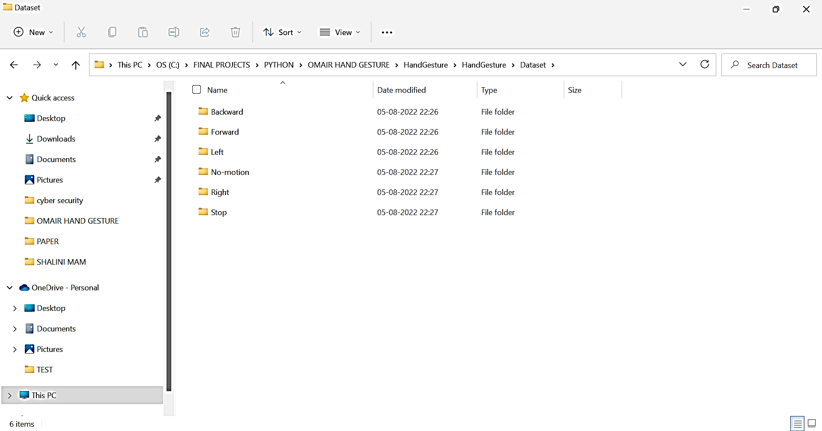

Fig.4.1 Hand Gesture Dataset Created for Training proposed Model

GUI (Graphical User Interface) is prepared in python for easy access to proposed model. Prepared dataset is loaded for training Modified CNN algorithm. Below screen is obtained after trained modified-CNN model.

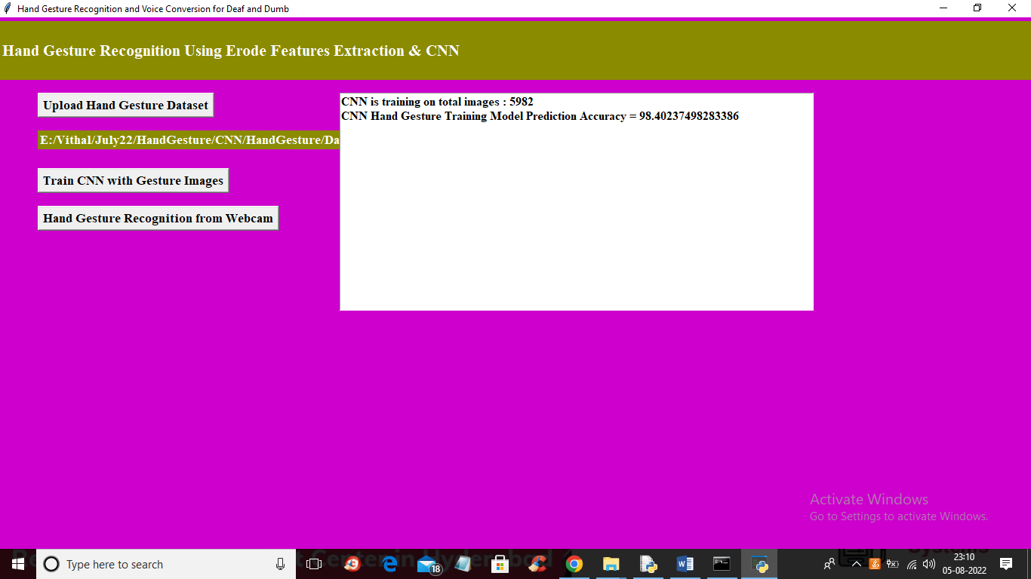

Fig. 4.2 Proposed model performance for prediction

In above results, CNN training model prediction accuracy is 98.4024 %. Original dataset is split to two groups as, 80% of the complete dataset is used for trained modified CNN algorithm while 20% of the complete data is used for prediction of hand gestures using trained model.

In below results, we have took green color bounding box , in which we need to show hand gesture and that gesture will be recognised by proposed modified CNN algorithm.

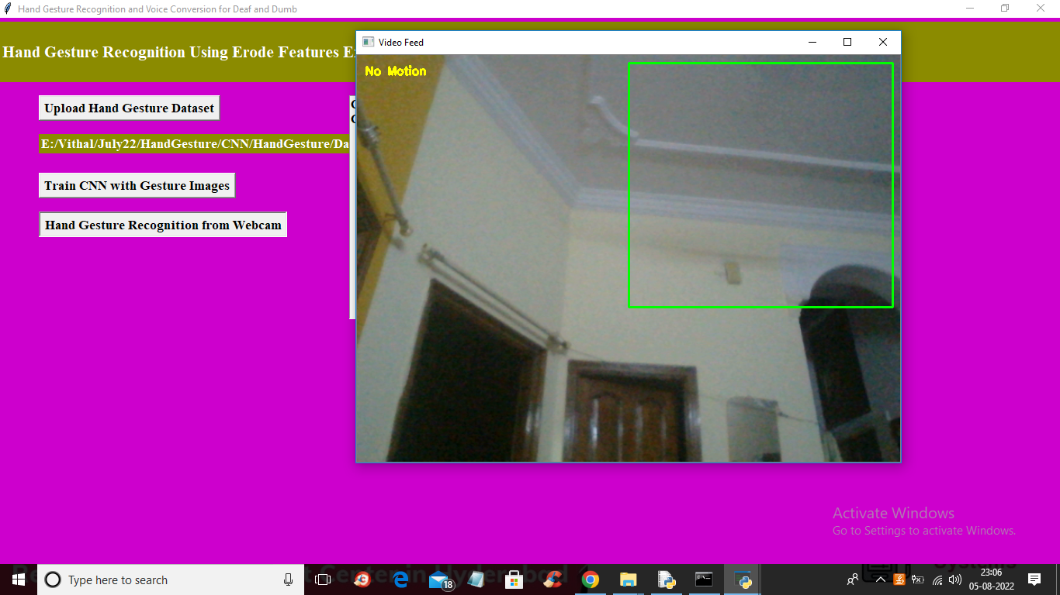

Fig.4.3 webcam data prediction using proposed model

When there is no gesture in front of webcam then recognised hand gesture is ‘No Motion’ based hand gesture. To get this type of prediction, image dataset with stable background, with human face, etc are trained.

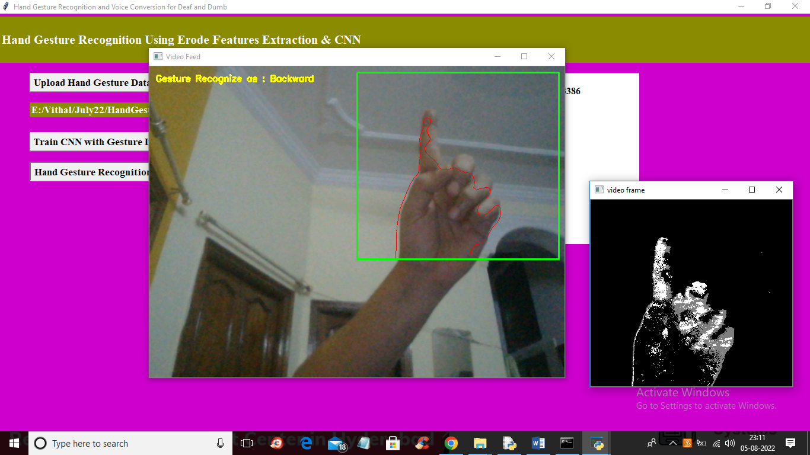

Fig.4.4 webcam data prediction using proposed model

Using proposed model hand gesture recognised is for ‘Backword’ motion. Above figure hand gesture is recognised which send ‘Backword’ motion instruction to robot car. This instruction is transmitted to robot car using Arduino controller.

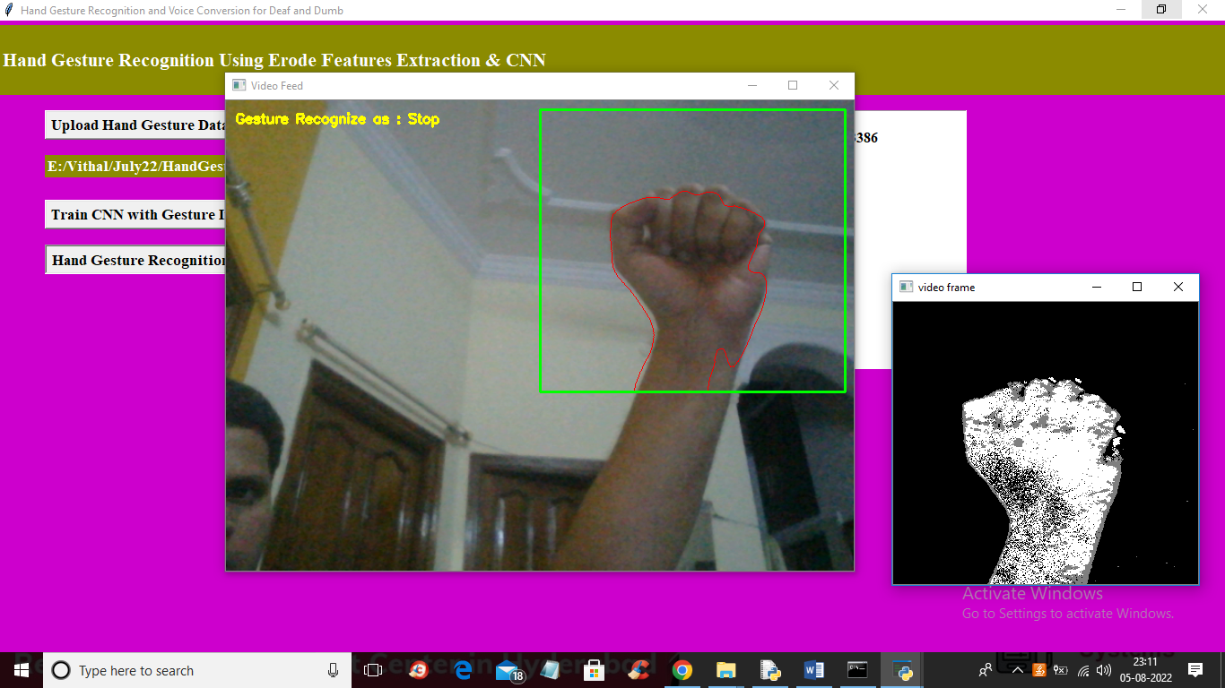

Fig.4.5 webcam data prediction using proposed model

Using proposed model hand gesture recognised is for ‘Stop’ motion. Above figure hand gesture is recognised which send ‘Backword’ motion instruction to robot car. Robot car will be stopped using this hand gesture and the instruction will be transmitted to arduino controller through serial port.

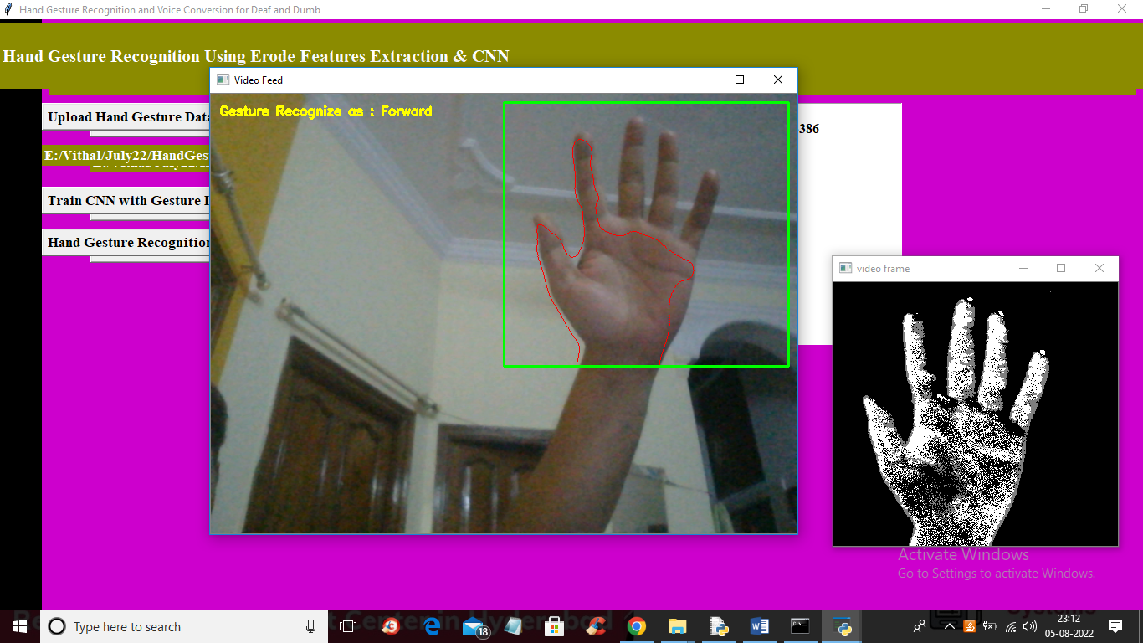

Fig. 4.6 webcam data prediction using proposed model

Using proposed model hand gesture recognised is for ‘Forword’ motion. Above figure hand gesture is recognised which send ‘Forword’ motion instruction to robot car. With this robot car can move straight forward, the instruction is transmitted from laptop/computer to robot car through serial port and Arduino executes the instruction.

1. **Conclusion and Future Scope**

Proposed modified CNN model performs superior compared to state of art technique such as random forest machine learning classifier for controlling movement of robot car. Modified CNN consists of unique structure of layers and these layers modifications is obtained to get higher accuracy. Robot car move in five different directions based on five different gestures and one is ‘No Motion’ gesture. Modified CNN algorithm gives 98.4024 % prediction accuracy while random forest classifier gives only 69% accuracy of real time hand gestures through webcam.

In future work, proposed work can be extended to complete real time application using Raspberry pi controller. GPS and some more sensors can be added to get location, environment details. Even obtained results can be published on private cloud.

**REFERENCES**

**[1] Saleem Ullah1, Zain Mumtaz1,etAl. (2019) ,An Automated Robot-Car Control System with Hand-Gestures and Mobile Application Using Arduino, © 2019 by the author(s). Distributed under a Creative Commons CC BY license,** <https://www.researchgate.net/publication/330182990>

**[2] Marc Peral. etAl. (2022) , ‘Efficient Hand Gesture Recognition for Human-Robot Interaction’, Journals & Magazines ,IEEE Robotics and Automation , Volume: 7 Issue: 4.**

**[3] Tanuja Jha etAl. (2018) , ‘Real Time Hand Gesture Recognition for Robotic Control’, 978-1-5386-5657-0/18/$31.00 c 2018 IEEE**

**[4] F. Arce, J. M. G. Valdez,” Accelerometer-Based Hand Gesture Recognition Using Artificial Neural Networks” in Soft Computing for Intelligent Control and Mobile Robotics Studies in Computational Intelligence, 2011.**

**[5] Gesture Controlled Robot using Kinect http://www.eyantra.org/home/projects-wiki/item/180-gesturecontrolled-robot-usingfirebirdv-and-kinect**

**[6] R. Wang, J. Popovic, ”Real-time hand-tracking with a color glove,” ACM Transactions on Graphics,2009.**

**[7] C.-C. Chang, I.-Y Chen, and Y.-S. Huang, "Hand Pose Recognition Using Curvature Scale Space", IEEE International Conference on Pattern Recognition, 2002.**

**[8] Chethana N S, Divya Prabha,M Z Kurian, “Static Hand Gesture Recognition System for Device Control”, International Journal of Electrical, Electronics and Data Communication, ISSN: 2320-2084, Vol 3,April-2015.**

**[9] Abhijit Nale, Ankush Barkade, Pravin Ekhande, and Shreyas Dayal, “Hand Gesture Recognition for Robotic Car Control”, IJARCST, Vol. 3, Issue 1 (2015).**

**[10] (DIP) Digital Image Processing by S. Jayaraman, S. Esakkirajan ,T. Veerakumar, August 10, 2013, ISBN: 978-0-07- 014479-8**